|  |  |  |  |
| --- | --- | --- | --- |
| **Name** | **Designation** | **Salary** | **Bonus** |
| **Robert** | **IT Manager** | **200000** | **25000** |
| **Daniel** | **Director** | **400000** | **50000** |

**After:**

|  |  |  |  |
| --- | --- | --- | --- |
| **Name** | **Designation** | **Salary** | **Bonus** |
| **Robert** | **IT Manager** | **200000** | **25000** |
| **Daniel** | **Director** | **400000** | **50000** |

1. **Select Table**

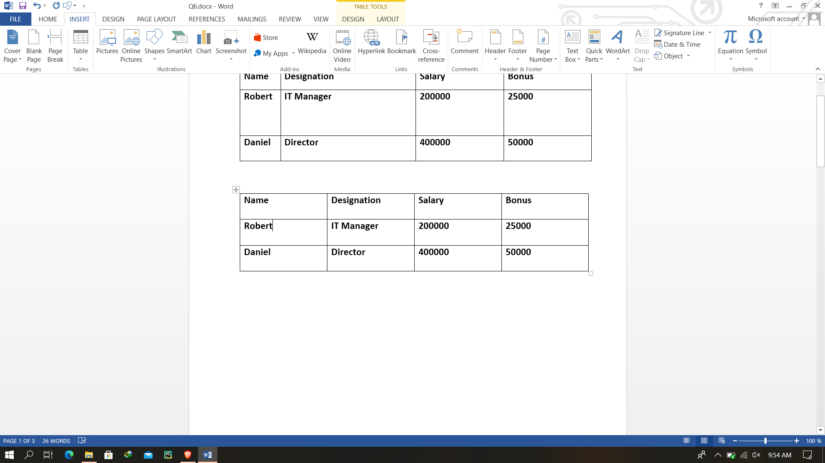

1. **Select Layout**

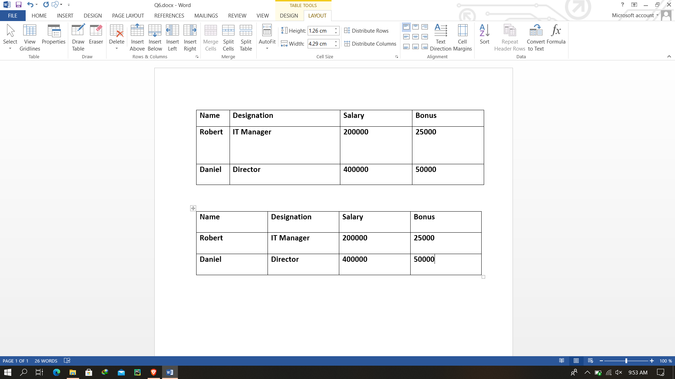

1. **Select Align Center**

